2018 Steering Rack

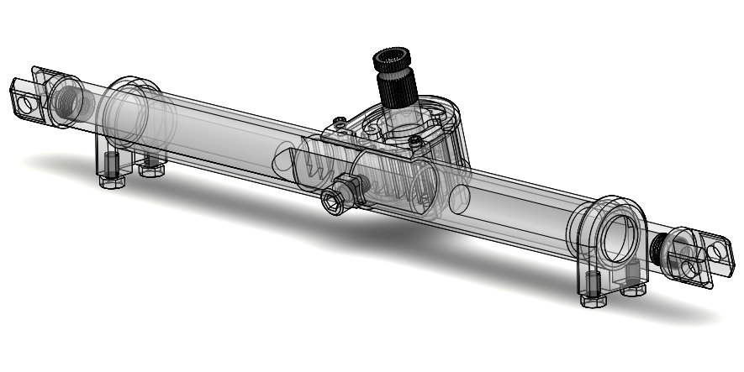

**Specifications:**

Total Weight = 1.64 lbs = 743.5 grams

Material: 6061 Aluminum, High Carbon Steel, Carbon Fiber

Length (Pickup to Pickup) = 15.96 in = 404.5 mm

Total Travel = 2.7 in = 68 mm

Speed Ratio = 4.81 in/rev